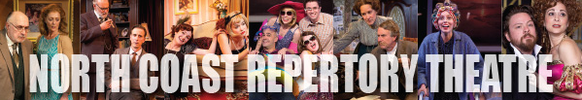
PRESS CONTACT: Nancy Richards – 917-873-6389 (cell)/nancy@northcoastrep.org
MEDIA PAGE: www.northcoastrep.org/press
PHOTOS BY: Aaron Rumley

FOR IMMEDIATE RELEASE, PLEASE:

GUNMETAL BLUES, MUSICAL SPOOF OF 1940s PRIVATE EYE FLICKS,
SAN DIEGO PREMIERE AT NORTH COAST REP
Performances Beginning Wednesday, January 14
With Opening Night, Saturday, January 17, at 8 pm
Running Through Sunday, February 8
Talkback with cast January 23
Book by Scott Wentworth
Music and Lyrics by Craig Bohmler and Marion Adler
Directed by ANDREW BARNICLE

SOLANA BEACH, North Coast Rep blazes into the New Year with a wildly entertaining musical take-off of 1940s film noir laced with mystery, music and demolished dreams. In the best Raymond Chandler tradition, the scene is set in the seedy, smoky Red Eye Lounge, where we meet a tough, trench-coated private eye, a sultry blonde and more blondes, and a jaded piano player who sends up complicated plot concoctions. Full of ballad numbers and rapid-fire dialogue, GUNMETAL BLUES is fresh, funny and thoroughly inventive. Reserve your tickets now for this captivating caper and see if you can figure out who done it.

Scott Wentworth wrote the book; music and lyrics are by Craig Bohmler and Marion Adler.

Andrew Barnicle directs Kevin Bailey*, Sharon Rietkerk*, and Jeffrey Rockwell* in this San Diego premiere.
Marty Burnett works his usual magic as scenic designer. Aaron Rumley* is the stage manager. The design team includes Matt Novotony (lighting); Alina Bokovikova (costumes); Chris Luessmann (sound); Benjamin Cole (properties/set dressing); Peter Hermann (hair & wigs); Andrea Gutierrez (production assistant), and John Finkbiner (scenic artist). Terry Berland conducted the Los Angeles casting.

GUNMETAL BLUES previews begin Wednesday, January 14, 2015. Opening Night on Saturday, January 17th at 8pm includes a post-show reception. There will be a special talkback on January 23rd with the cast and artistic director. It will play Wednesdays at 7pm, Thursdays through Saturdays at 8pm, Saturday and Sunday matinees at 2pm with Sundays at 7pm, through February 8, 2015. (See Schedule below.) North Coast Repertory Theatre is located at 987 Lomas Santa Fe Drive, Ste D, Solana Beach, CA 92075. Ticket range $40 - $51 and $3 off for seniors, students and military. Call 858-481-1055 or visit www.northcoastrep.org to purchase tickets.
Production Sponsor: Kathleen Bell Flynn and Steve Flynn

For background information and photos, go to www.northcoastrep.org/press.
Please follow North Coast Repertory Theatre on social media as well on Facebook at https://www.facebook.com/pages/North-Coast-Rep/128553240497901
Twitter: https://twitter.com/NorthCoastRep
YouTube: http://www.youtube.com/user/NCRTheatre?ob=0

Busy director Andrew Barnicle and his talented cast are available for interviews by phone, in person, and in- studio. For more information and to arrange interviews or press tickets, please contact Nancy Richards at nancy@northcoastrep.org, or 917-873-6389 cell.

FACT SHEET

WHAT: NORTH COAST REPERTORY THEATRE presents
GUNMETAL BLUES
Book by Scott Wentworth
Music and Lyrics by Craig Bohmler and Marion Adler
Directed by Andrew Barnicle

CAST: Kevin Bailey,* Sharon Rietkerk* and Jeffrey Rockwell*

WHERE: North Coast Repertory Theatre
987 Lomas Santa Fe Drive, Ste. D
Solana Beach, CA 92075

SCHEDULE*: Previews: January 14-16, 2015
Opens: January 17, 2015, at 8 pm
Closes: February 8, 2015
Wed. @ 7pm, Thurs-Sat @ 8PM; Sat & Sun @ 2PM, Sun @7pm
Talkback with cast & director: January 23, 2015

PRICES: Adults: $40 - $57

DISCOUNTS: Seniors, Students, Military $3 off

BOX OFFICE (858) 481-1055 or www.northcoastrep.org

JANUARY
SUN | MON | TUE | WED | THU | FRI | SAT
 |  |  | 14  Preview  8pm | 15  Preview  8pm | 16  Preview  8pm | 17  OPENING  8pm
18  2pm & 7pm | 19 | 20 | 21  7pm | 22  8pm | 23  8pm  talkback | 24  2pm & 8pm
25  2pm & 7pm | 26 | 27 | 28  7pm | 29  8pm | 30  8pm | 31  2pm & 8pm
FEB 1  2pm & 7pm | 2 | 3 | 4  7pm | 5  8pm | 6  8pm | 7  2pm & 8pm
8
2pm

BACKGROUND:
North Coast Repertory Theatre’s 2014-2015 -Season 33 Neil Simon’s Chapter Two (February 25 - March 22), back by popular demand, is the first play ever produced by North Coast Rep, and is next on the docket. Based on events in Simon’s life, this charming comedy revolves around the recently widowed George and his neighbor, the recently divorced Jennie. Neither of these bruised souls is eager to reconnect with the opposite sex. Their journey of meeting, dating and forming a relationship is laced with Neil Simon’s golden touch. Romantic, rueful, touching and funny, this play is certain to delight and entertain. The fourth San Diego premiere of the season, Unnecessary Farce (April 15 – May 10), presents the perfect setup for a laugh-filled evening at the theatre. There’s an embezzling mayor, his female accountant who can’t stay dressed, two undercover cops, nefarious hit men, and of course, videotape. This fast-paced farce promises to leave audiences howling with laughter. June brings master playwright Harold Pinter’s Betrayal (June 3 – 28), a play that explores the shifting balance of power within a love triangle. Filled with taut drama and deception, the story unfolds in reverse chronology as the audience takes this treacherous journey with characters who are compelling and brimming with human frailty. Passionate, explosive and surprisingly funny, Betrayal is considered one of Pinter’s most innovative and influential works, one that is

certain to provoke lively discussion long after the curtain falls. Season 33 concludes with Side By Side With Sondheim (July 15 – August 9). Revel in the sophistication, wit, insight, heart and genius of Broadway’s most innovative and influential artist, composer-lyricist Stephen Sondheim. Audiences will hear familiar favorites from such shows as Company, Follies, A Little Night Music, A Funny Thing Happened on the Way to The Forum, Westside Story, Gypsy and so many more. An unmatched evening of enchantment for musical theatre fans.

About the North Coast Repertory Theatre
North Coast Repertory Theatre is a professional Equity theatre founded in 1982 by Olive and Tom Blakistone. Currently celebrating its 33rd season, North Coast Rep has received critical acclaim from media and audiences alike, and has evolved into one of the area’s leading performing arts organizations. North Coast Rep prides itself on employing the majority of its actors from Actors’ Equity Association for its high quality, award-winning productions, and staging works by established and emerging playwrights. Throughout its history, North Coast Rep has created a platform where artist and audience thrive through the intimacy of live theatre, recognizing the power of theatre to challenge complacency, revitalize the imagination, nurture the unexpected and embrace the variety and diversity in our lives.

BIOS:

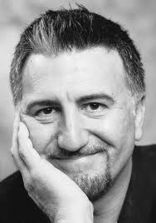 SCOTT WENTWORTH (Book) is a director, actor and playwright. As Associate Artist for Shakespeare Santa Cruz he directed Love’s Labour’s Lost and Henry IV, Parts I and II; for the Shakespeare Theatre of New Jersey, Othello, As You Like It, The School for Scandal, Henry V and The Winter’s Tale. As Associate Artist at the Indiana Repertory Theatre he created its annual production of A Christmas Carol, as well as directing Ghosts, Othello, Candida, Hedda Gabler and the world premiere stage adaptation of The Magnificent Ambersons. Other directing credits include Richard III at Vancouver’s Bard On The Beach, an award winning Much Ado About Nothing at the Hilbury Theatre, Romeo and Juliet at the Denver Center and the Citadel Theatre’s Macbeth in collaboration with Robin Phillips. He directed the late Douglas Campbell as Falstaff in both parts of Henry IV at Canada’s Stratford Festival where next season he will direct Pericles. He has written the book for two musicals; Gunmetal Blues and Enter The Guardsman (music and lyrics by Craig Bohmler and Marion Adler). Gunmetal Blues was workshopped at the Eugene O’Neill Theatre Center and premiered Off-Broadway in 1992. Enter The Guardsman had its world premiere at London’s Donmar Warehouse, where it received an Olivier nomination for Best New Musical. He has also created adaptations of Marlowe’s Dr. Faustus, Ibsen’s Ghosts and Dumas’ The Man In The Iron Mask which received its world premiere at Shakespeare Santa Cruz in 2012. Mr. Wentworth is a Tony nominated actor who is celebrating his 20th season with the Stratford Shakespeare Festival.

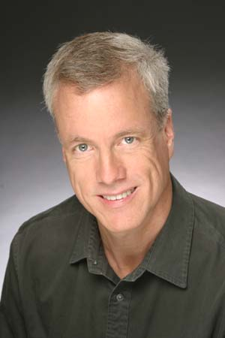 CRAIG BOHMLER (Music & Lyrics) (b.1956) is a composer and pianist whose works have been frequently performed in Europe and North America. Primarily a composer for the Lyric Theater and the solo voice, Mr. Bohmler has three operas and ten musicals to his credit as well as 190 songs and numerous choral works. He has written operas for the Houston Grand Opera, Opera San Jose, and Arizona Opera. His musicals are performed regularly. Gunmetal Blues has had over 200 productions. Enter The Guardsman won first prize in the International Musical of the Year competition and premiered in London's West End where it was nominated for an Olivier Award for Best Musical. The Quiltmaker’s Gift was commissioned by Phoenix theatre where it is an annual holiday offering. Mountain Days had a theatre built for it so it could become an annual event. It has had six productions there. His musical, The Haunting of Winchester, opened the San Jose Repertory Theatre’s 25th anniversary season. Orchestral works include Saints and Pentimento, both commissioned and recorded by the San Jose Chamber orchestra. Mr. Bohmler has been the recipient of several grants including three NEA grants and three "Meet the Composer" grants. In his other life, he is able to exploit his Texas roots as musical director and arranger for the 3 Redneck Tenors. Presently he is composer-in-residence for Arizona Opera where he is writing the first American Western Opera based on Zane Grey’s Riders Of The Purple Sage. He is published by Santa Barbara Music Publishing, Dramatic Publishing, Samuel French and Theatrical Rights Worldwide as well as recorded by Columbus, Centaur, Original Cast, and BMS records. More detailed information and recordings may be found at Craigbohmler.com

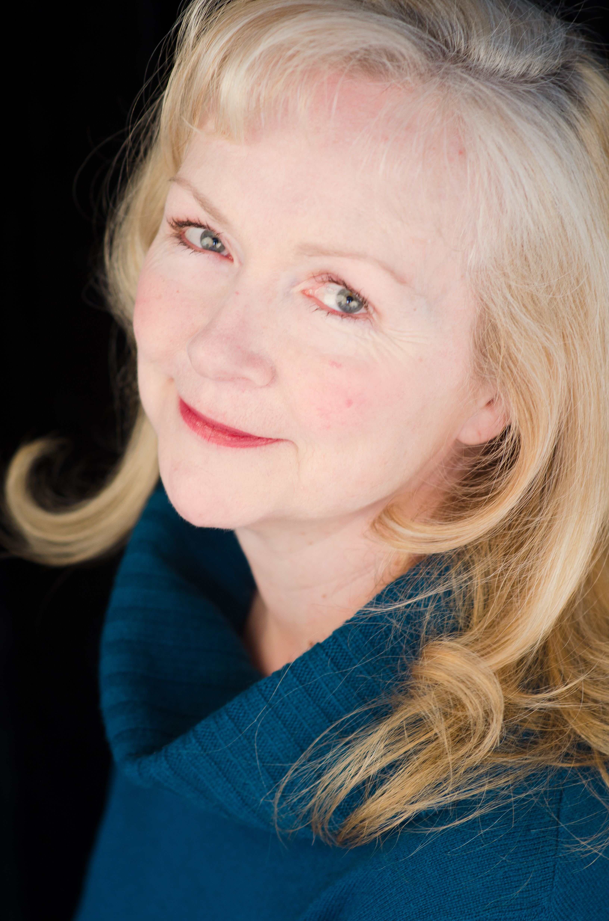 MARION ADLER (Music & Lyrics) is a lyricist, singer and actor whose work has been seen and produced across North America and Europe. Her musical, Enter The Guardsman, was premiered in London’s West End at the Donmar Warehouse and nominated for an Olivier Award for best New Musical. Enter The Guardsman went on to become the most produced new musical in the U.S. in the 2001-2002 season according to American Theatre Magazine, enjoying a full season of performances at the Oregon Shakespeare Festival and productions at San Diego's Old Globe, The Indiana Repertory Theatre and the Shakespeare Festival of New Jersey. Ms. Adler’s musical, Gunmetal Blues, premiered off -Broadway in 1992 and has enjoyed numerous productions, including outings in Osaka, Japan, Vancouver, Winnipeg, Santa Barbara, Tucson and Santa Cruz, CA. In 2000, Ms. Adler was a winner of the Kleban Award for her body of work as a lyricist.

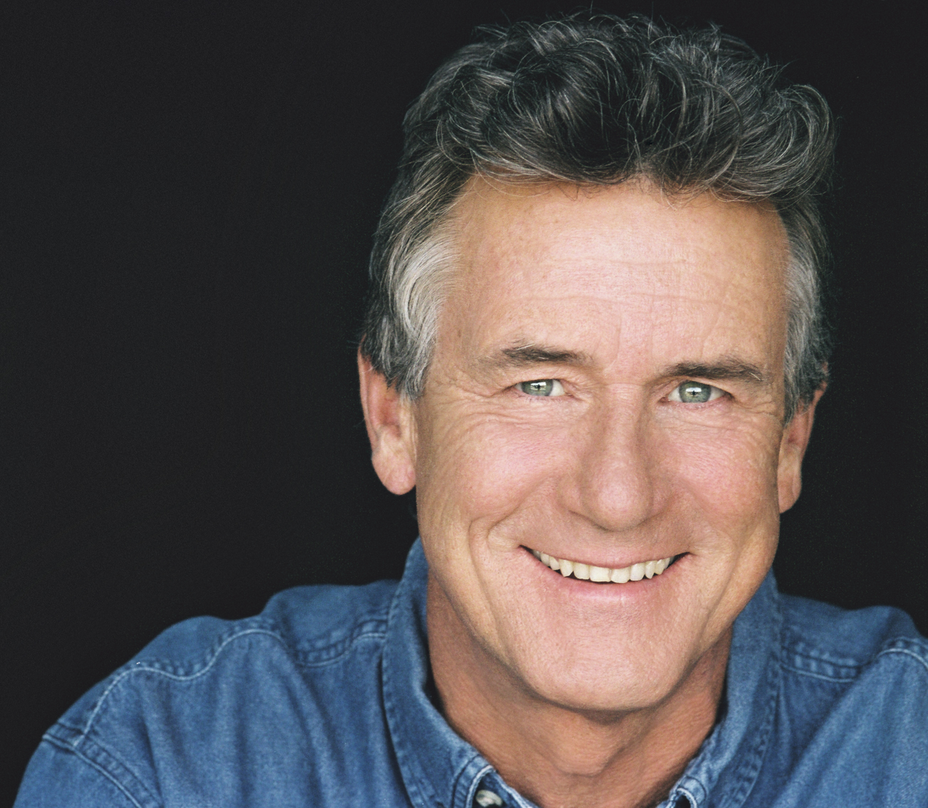 ANDREW BARNICLE (Director) has now directed eleven plays at North Coast Rep, including the recent Who Am I This Time?, The Odd Couple, and The Lion In Winter, and was recently seen as General Daniel Sickles in Faded Glory. Andrew served as artistic director of The Laguna Playhouse from 1991 through 2010. In that time he produced over 100 Playhouse shows and directed over 40 of them, including many World, U.S., West Coast and Southern California premieres. Recent directing projects at Laguna include Neil Simon’s Chapter Two, Willy Russell’s Shirley Valentine, Noel Coward’s Private Lives, Ron Hutchinson’s Moonlight and Magnolias, (which also played the La Mirada Theatre for the Performing Arts as a co-production with McCoy/Rigby Entertainment, and Burbank's Colony Theatre), Michael Hollinger's An Empty Plate in the Café du Grand Boeuf and Red Herring, Yazmina Reza’s Art, the World Premieres of Bernard Farrell's The Verdi Girls, and Richard Dresser’s The Pursuit of Happiness, the U.S. premiere of Farrell’s Many Happy Returns, Steve Martin’s The Underpants, and Somerset Maugham’s The Constant Wife. In the past few years, he directed Blame It On Beckett and Stephanie Zimbalist in Sex and Education and at the Colony Theatre, Shirley Valentine and the world premiere of Ken Levine’s A Or B? at the Falcon Theatre, The Irish Curse at the Odyssey Theatre, Private Lives at the Rubicon Theatre in Ventura, and Present Laughter at Chapman University. He has also directed at San Diego’s Theatre at Old Town, Michigan’s Meadow Brook Theatre, Gunmetal Blues, Rounding Third, Charles Evered's Celadine at the Colony Theatre, and The Foreigner at the San Jose Repertory Theatre. THIS ARTIST IS SPONSORED BY DAVE AND HEIDI HODGES

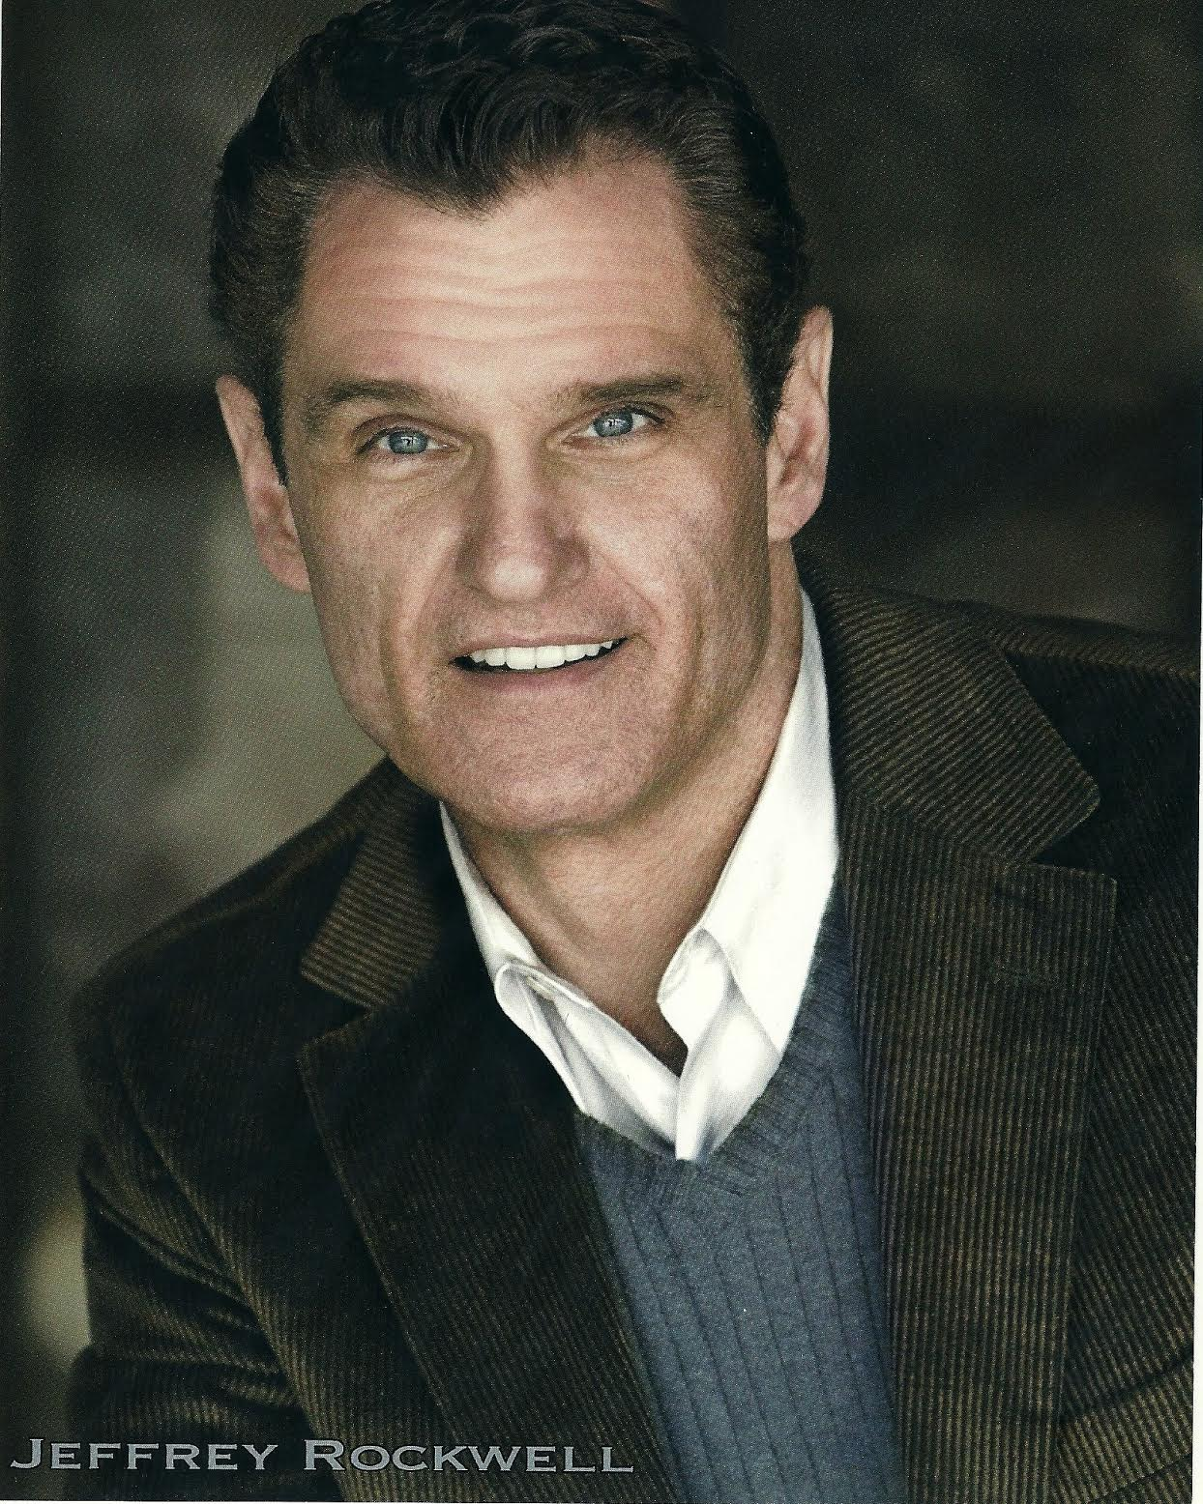 JEFFREY ROCKWELL* (The Piano Player/Music Director) played Buddy Toupee at the Laguna Playhouse and LA Colony Theatre, and recorded the role for the premiere cast CD. Other stage performances include: 2 Pianos 4 Hands (regional companies), Young Frankenstein (Musical Theatre West), How the Grinch Stole Christmas (San Diego's Old Globe), South Pacific (Sierra Rep), My Fair Lady and Into the Woods (San Diego Starlight Bowl), and Musical of Musicals- the Musical! (Laguna Playhouse, the Colony Theatre). He composed the children's opera Rip Van Winkle for San Diego Opera's Opera for Kids program, and music and lyrics for stage adaptations of Ray Bradbury's Dandelion Wine and Francois Truffaut's The Last Metro (New York and LA productions). Love and thanks to JD. THE ARTIST IS SPONSORED BY JOHN AND CATHY WEIL

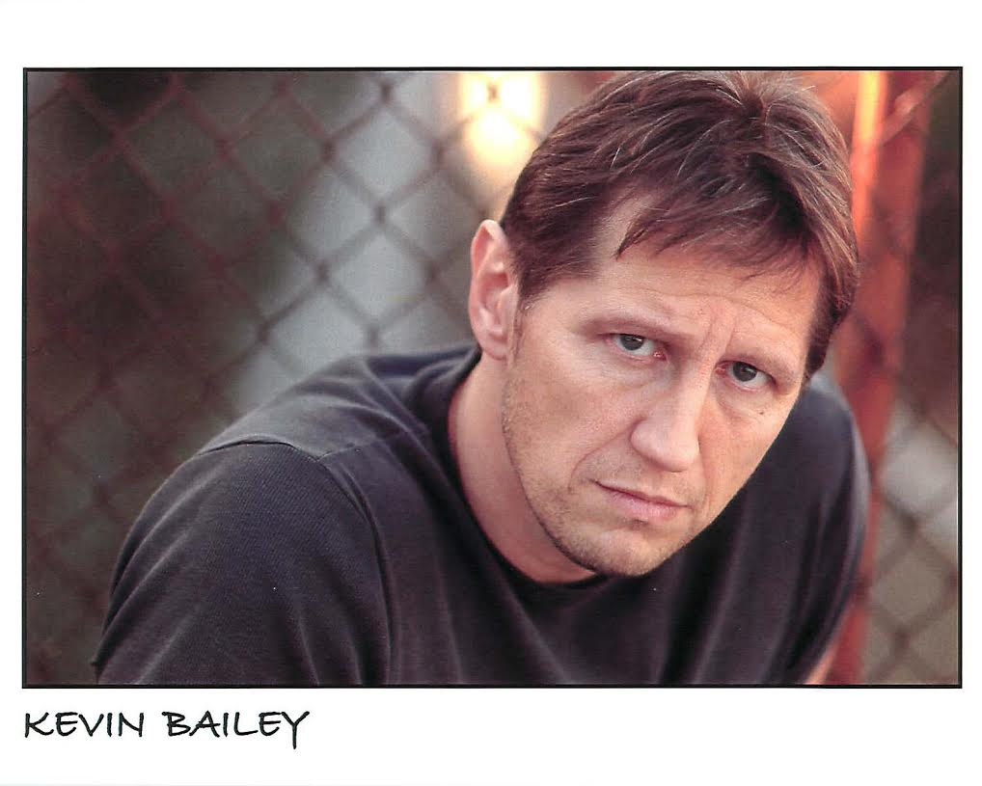 KEVIN BAILEY* (The Private Eye) Broadway: original company of The Lion King (Scar, also LA Company), Annie Get Your Gun, with Bernadette Peters (Sitting Bull u/s Tom Wopat). Off-Broadway: The Doctor’s Dilemma (Walpole), A Midsummer Night’s Dream (Demetrius). National Tours: Jesus Christ Superstar (Pilate). Regional: Grinch in The Grinch… (Old Globe – two seasons), Fred Graham in Kiss Me Kate, Frank Butler in Annie Get Your Gun, (Ovation Nomination), title role Jekyll & Hyde. Hollywood Bowl: Amadeus as Venticello, starring Michael York and Neil Patrick Harris. Los Angeles credits: The Ghost & Mrs. Muir (Miles Blaine) and Dorian (Henry Lord), with Greater Tuna stars, Jaston Williams and Joe Sears The Foreigner (David Lee) and The Fantasticks (El Gallo). He is Producing Director of the award winning NoHo Arts Center in North Hollywood, with partner James Mellon. For William, Nora and James. THE ARTIST IS SPONSORED BY TOM AND DONNA GOLICH

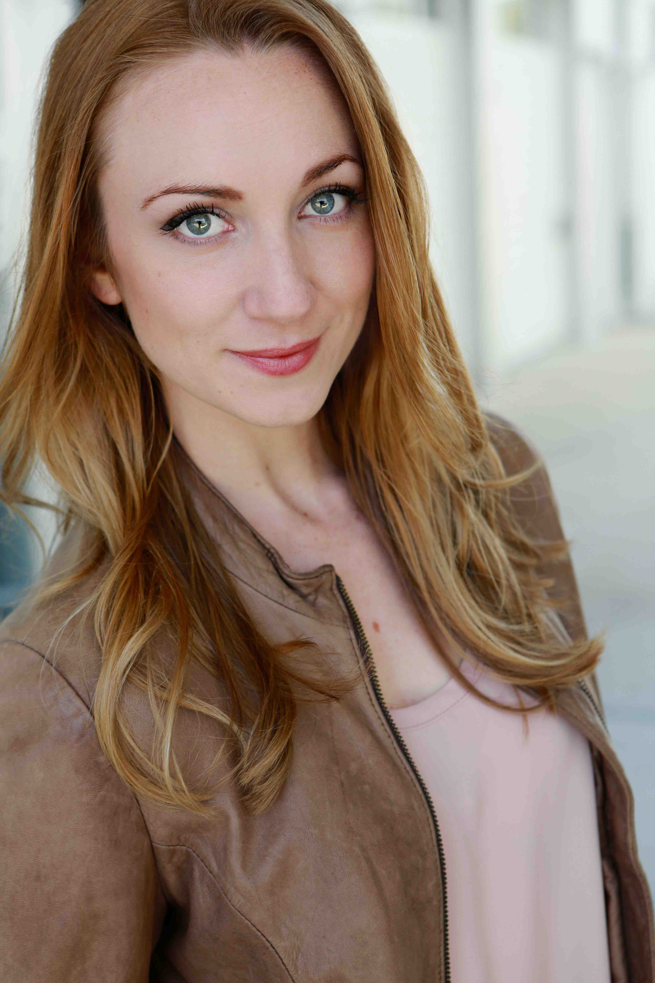 SHARON RIETKERK* (The Blonde) is making her North Coast Repertory debut. Regional credits include: TheatreWorks Silicon Valley: Marry Me A Little (Theatre Bay Area Best Actress Award), Little Women, Secret Garden, San Jose Repertory Theater: A Minister’s Wife, Lyric Theater of Oklahoma: Triangle, Center REPertory Theater: Life Could Be a Dream, Rumors, Xanadu, 42nd Street, Moon: Little Me, Strike up the Band. Next up she will be originating the role of Elinor in a new musical adaptation of Sense and Sensibility by Paul Gordon at Chicago Shakespeare Theater. Ms. Rietkerk has also performed with the San Francisco Opera Guild, Grammy-nominated Bay Brass, and Bear Valley Symphony. She is a graduate of University of California, Irvine. THE ARTIST IS SPONSORED BY MARY KAY WEST

MATT BEST (Woodwinds) has been a professional woodwind musician, technician, and private instructor for 20 years. After studying music in college he traveled the globe as a woodwind musician and music director aboard cruise ships. In 2013 he founded mattbestmusic.com which features his own pro-level woodwind repair shop. Matt performs regularly in various genres including symphony orchestras, rock bands, jazz bands, and musical theatre. He also enjoys teaching private students and is proud to have helped several local students pass auditions into the most prestigious honor bands in the region. THE ARTIST IS SPONSORED BY JIM AND NANCY SAW

TOM VERSEN (Drums/Percussion) I am thrilled to be a part of this beautiful production. (NCRT) Back to Bacharach and David, Jacques Brel, I Love you Because, Spelling Bee, Dames at Sea. (San Diego Rep) Respect, John Doe the Musical, Six Women with Brain Death, Always Patsy Cline, Bessie’s Blues, Menopause the Musical, (LPT) Music Man, Boomers, The Secret Garden, The Mysteries of Edwin Drood, Pete ‘n’ Keely. CCHS Modern Millie, Godspell (Off Broadway) – Suds. Thanks to all of you who support the arts, and special thanks to my friends and family. Enjoy the show….http://www.tandtcreative.com. THE ARTIST IS SPONSORED BY HON.H. LEE AND MAJORIE SAROKIN

FRED UBALDO JR. (Bass) has built an extensive resume of work, ranging from cruise ship show bands to conventions to salsa and dance orchestras. He has played the shows of Cab Calloway, Frankie Avalon, Michael Crawford and Clay Aiken. In addition, he's been heard in productions of Grease, Chess, Joseph And The Amazing Technicolor Dreamcoat, and Elton John's Aida. Fred was last seen at North Coast Repertory Theater in Jacques Brel Is Alive And Living In Paris, and Back To Bacharach And David.
THE ARTIST IS SPONSOREDBY DANIEL POWELL

AARON RUMLEY* (Stage Manager) North Coast Repertory Theatre: Who Am I This Time?; Broken Glass; Two by Pinter: The Lover and the Dumb Waiter, THIS, The Lion in Winter, Heroes, Lend Me a Tenor, My Name is Asher Lev, The Drawer Boy, Becky’s New Car, Voice of the Prairie, Ghosts, Glorious!, Talley’s Folly, Over the Tavern, Rabbit Hole, The Dresser, Don’t Dress for Dinner, Madagascar, Mornings at Seven, String of Pearls, Dracula, Rashomon, Wit, A Moon for the Misbegotten, Leading Ladies, Collected Stories, Halpern & Johnson, Romeo and Juliet, The Bungler, The Chosen, A Life in the Theatre and The Rainmaker. North Carolina Theatre: Talley’s Folly, Picnic, The Miser and On Golden Pond. Aaron received a B>A> in Theatre from the University of North Carolina at Wilmington, and is the production manager at the North Coast Repertory Theatre. Aaron is a Member of Actors’ Equity Association. THE ARTIST IS SPONSORED BY BARBARA BURRILL AND DENNIS COOPER

DESIGN TEAM

MARTY BURNETT (Resident Scenic Designer) Marty begins his 23rd season as Resident Designer/Technical Director at North Coast Rep. He has designed the last 166 shows. Other venues include Laguna Playhouse, Portland Stage Company, Drury Lane (Chicago), Claridge Hotel (Atlantic City), Union Plaza, Sahara Hotel, Hacienda in
Las Vegas, Coronado Playhouse, Scripps Ranch Theater, Harrah’s Lake Tahoe. Marty is a proud alumni of Creighton University in Omaha, Nebraska.

MATT NOVOTNY (Lighting Design) recently designed the lighting for Romance Romance, Faded Glory, Mandate Memories, The School For Lies, Who Am I This Time?, Broken Glass, Man with a Load of Mischief, Perfect Wedding, Becoming Cuba, The Odd Couple, Time Stands Still, Educating Rita, The Underpants, Dames at Sea, Two by Pinter: The Lover and The Dumb Waiter, THIS, Visiting Mister Green, Lend Me a Tenor, Five Course Love, My Name Is Asher Lev, King O’ the Moon, Ghosts, Glorious, I Love You Because, Old Wicked Songs, Rabbit Hole, Shipwrecked!, The Dresser, Don’t Dress for Dinner, Mornings at Seven, Baby and Rashomon at North Coast Rep. He’s currently the Director of Production for Lyric Opera San Diego. Lighting designs include: Iolanthe, The Merry Widow, The King and I, Countess Maritza, and The Mikado. San Diego: Das Barbecu, The Wiz, West Side Story and Rumors. Regional: Yankee Doodle Dandy (Seattle), Noises Off! (Boston), The Game, (Washington D.C.) and Primal Twang, a guitar concert featuring six Grammy-winning artists. Matthew holds a B.A. in Technical Theatre from San Diego State University, and an M.F.A. from Boston University.

ALINA BOKOVIKOVA (Costume Design) has designed more then 50 different productions and is proud to be a resident designer at North Coast Repertory Theatre. Her recent credits include Freud's Last Session, Fallen Angels, School for Lies, Romance, Romance, Words By, Broken Glass. Other favorite works are Bird Lady (Link Theatre, Chicago) A Doll's House (The Old Globe Theatre), A Raisin in the Sun (MOXIE Theatre), Camino Real (Patté Award, opera La Traviata. Ms. Bokovikova has an M.F.A. in Costume Design from UC San Diego and a Masters Degree in Education from Russia. She is teaching at UC San Diego, Fashion Institute of Design & Merchandising and Grossmont College.

CHRIS LUESSMANN (Sound Design) North Coast Rep: The 25th Annual Putnam County Spelling Bee, The Big Bang, Jaques Brel is Alive and Well and Living in Paris, Baby, Dracula (Patté Award,) and A Christmas Carol (Patté Award.) Off Broadway: The Third Story. La Jolla Playhouse: Chasing the Song, Billy Crystal’s 700 Sundays, The Darrell Hammond Project. San Diego Repertory Theatre: Long Story Short. Lambs Players Theatre: South Pacific. Moonlight Stage Productions: Les Misérables, Catch Me If You Can, My Fair Lady, Young Frankenstein, The Wizard of Oz (Craig Noel Award.) Scripps Ranch Theatre: Red Herring. Chris earned his BA from UCLA and his MFA from UCSD.

BENJAMIN COLE (Properties Designer/Set Dressing), is proud to be part of the North Coast Rep family as Artistic Associate. Additional Properties Designs/Set Dressing at NCRT includes: Freud’s Last Session, Fallen Angels, Romance/Romance, Faded Glory, Mandate Memories.

PETER HERMAN (Hair & Wig Design) has previously designed wigs for over 30 North Coast Rep productions including: Romance Romance, Faded Glory, Mandate Memories, The School For Lies, Honky-Tonk Angels, Travesties, I Love You Because, Little Women, My Name is Asher Lev and Five Course Love. He has also designed costumes for past North Coast Rep productions of 25th Annual Putnam County Spelling Bee, The Big Bang, Madagascar, and Jacques Brel is Alive and Well and Living in Paris. Peter teaches wig and makeup design at San Diego State University. He is glad to be part of the creative team on this show.

JOHN FINKBINER (Scenic Artist) John has been a member of the North Coast Repertory Theatre staff for more than six years. His favorite shows are Halpern and Johnson, SHIPWRECKED!, The Dresser and Jacques Brel. John received his BA degree at UCLA’s School of Theater, Film and Television in 1991. John is also an accomplished singer/songwriter and performs with his band, the Stereotypes. His music has been featured on Showtime’s “Californication,” Fox’s “Bones” and NBC’s “Knight Rider,” among others. John lives with his wife Judi and his son John Gibsonin Leucadia.

TERRY BERLAND (Los Angeles Casting Director) casts films including “Whistler and The Case For Beauty”, “Exiles in Hollywood,” “Child of God”, “Maladies, Isaac Stern: Life’s Virtuoso” and TV animation “Invader Zim”. Theatre: North Coast Repertory Theatre, Mandate Memories, Fallen Angels and Gunmetal Blues,. I am proud to cast both celebrity and everyday working actors in commercials branding products in voice-over, animation and on-camera genres. Some infamous such as the voice of the Taco Bell Chihuahua to well known Old Navy, Apple IPad spots and others where the talent have successful careers in television and film and you don’t even know their names. Theatre is the strong foundation of an actor’s career and I am happy to have the opportunity to cast for this North Coast Rep production.

#####

